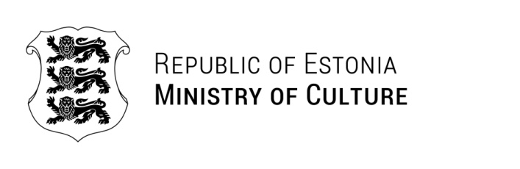

Ms Otsetswe K. Koboyankwe
Acting Chief Executive Officer
National Arts Council of Botswana
OKoboyankwe@nacb.co.bw | 12.06.2025 | No 9-10/646-1

Invitation

As a follow-up to the fruitful discussions with representatives of the National Arts Council of Botswana during my visit to Gaborone in March 2025, the Ministry of Culture of the Republic of Estonia would like to invite a delegation formed by the National Arts Council of Botswana to a study visit to Estonia in November 2025.
The purpose of the potential study visit is to strengthen Botswana Creative and Culture Industries (CCI) national development policy contexts and support the achievement of Sustainable Development Goals. The focus of the potential visit is on film and audio-visual culture. The visit would include meetings and discussions with several CCI stakeholders representing government, civil society, private sector, and academia as well as a participation at PÖFF – one of the 15 A-list film festivals globally that takes place in Tallinn, Estonia 7-23 November 2025.
The visit depends upon a successful TAIEX funding application that must be submitted by the National Arts Council of Botswana to the European Commission prepared in cooperation with the European Union Delegation in Botswana and the Estonian Ministry of Culture. The costs of travel, accommodation, and per diem of the study visit’s participants would be covered by the European Commission. Usually, the TAIEX study visit lasts 2-5 days and the delegation consists of 3-5 officials from public administrations. The details of the TAIEX instrument and study visit agenda will be discussed and agreed in detail further on in the process.
Please do not hesitate to contact us in case you have any further questions.

Yours sincerely,

Kristiina Alliksaar
Secretary General

Madli Kumpas +372 6441431
Madli.Kumpas@kul.ee

